ETEFOP tss php environment on16September 2025 Group members:
1.NIYOKWIRINGIRWA jean damour
2.NKURUNZIZA kelvin
3.ISHIMWE josue

PHP ENVIRONMENT PREPARATION REPORT AND TESTING STEPS
STEP1: open browser
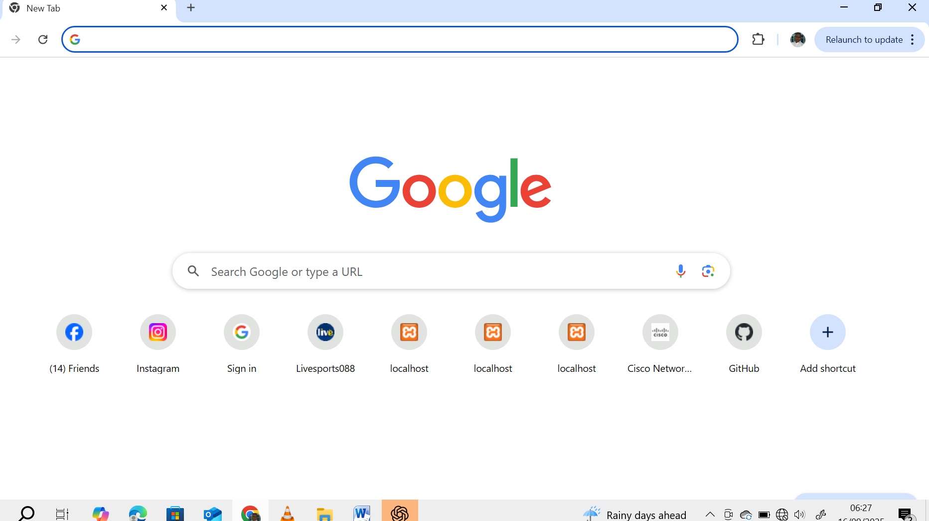
Step2:type “xampp download” from search bar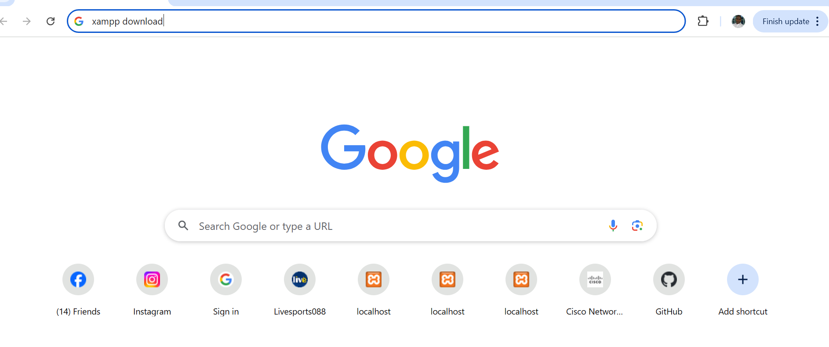

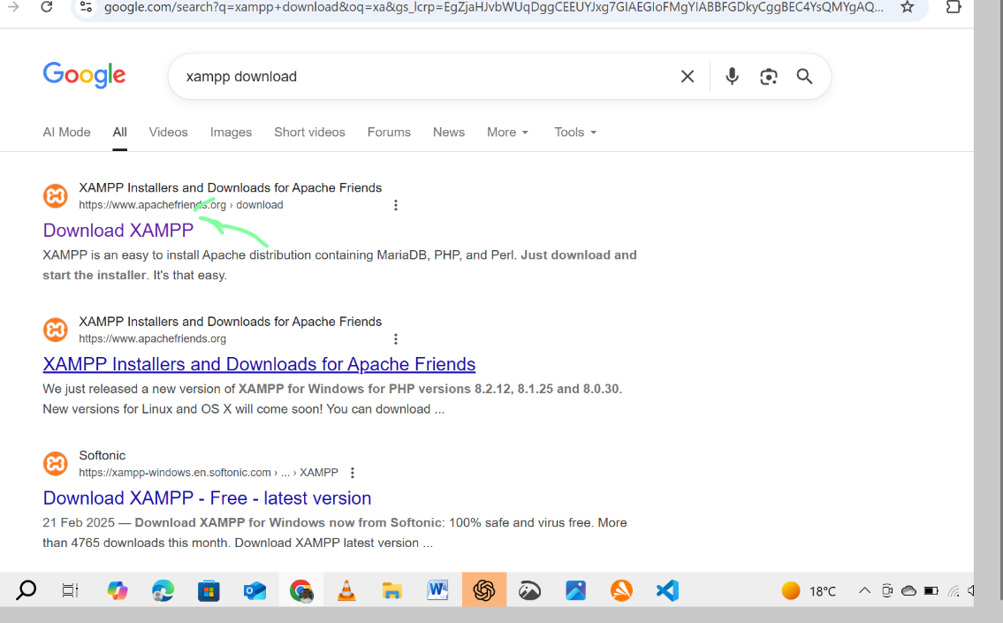
Step3: connect my SQL and apache with php in xampp
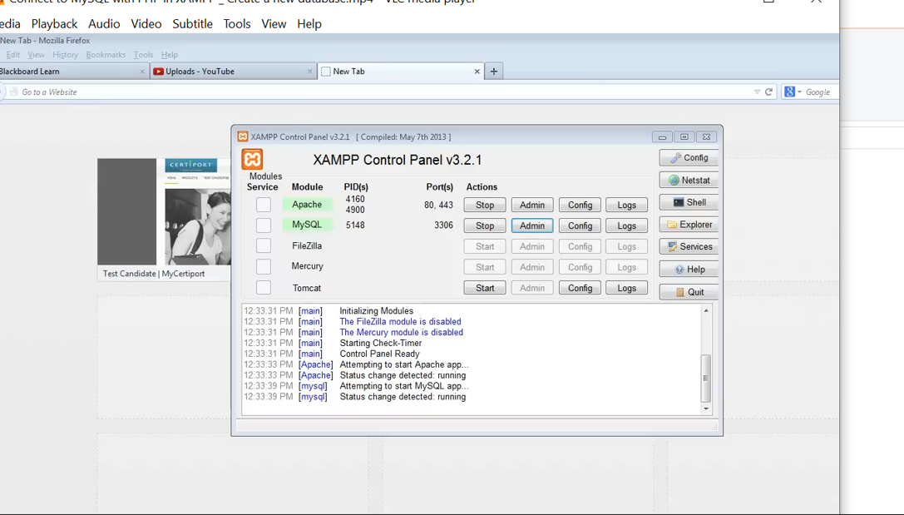
Step4: open file folder, click this pc, press to the xampp then double click
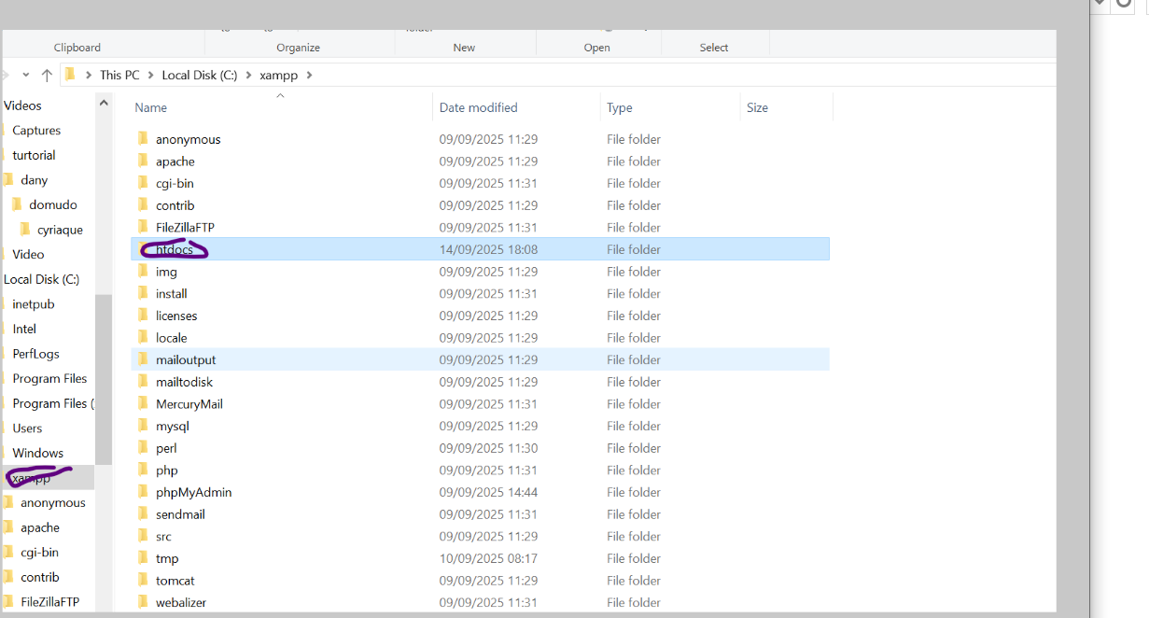
Step5: press htdocs then create new folder
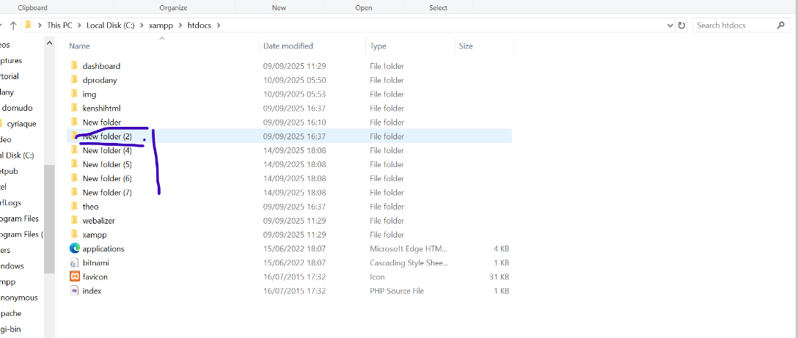
Step6: open vs code studio setup and install
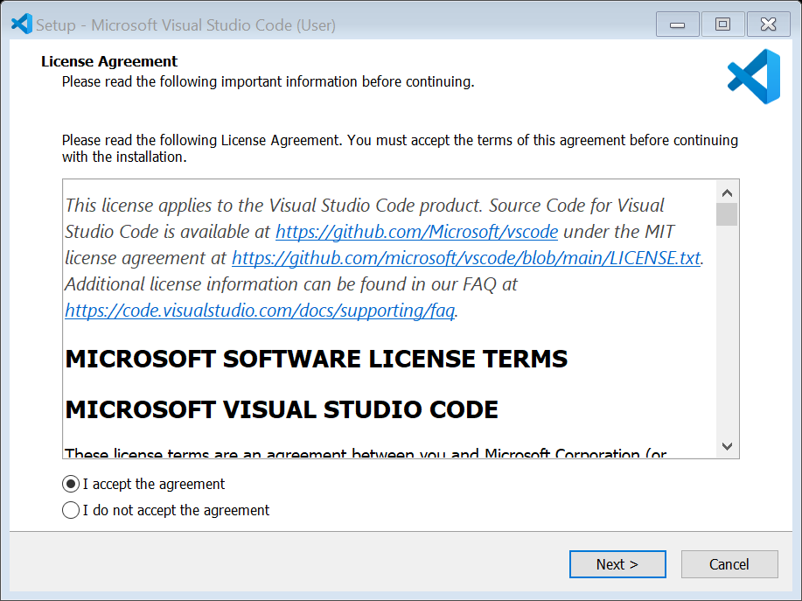
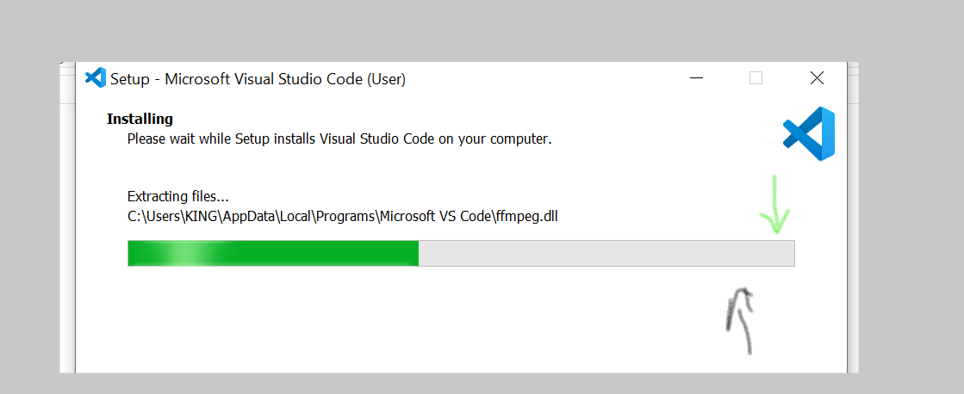
Step7: open created folder from htdocs into VSCODE
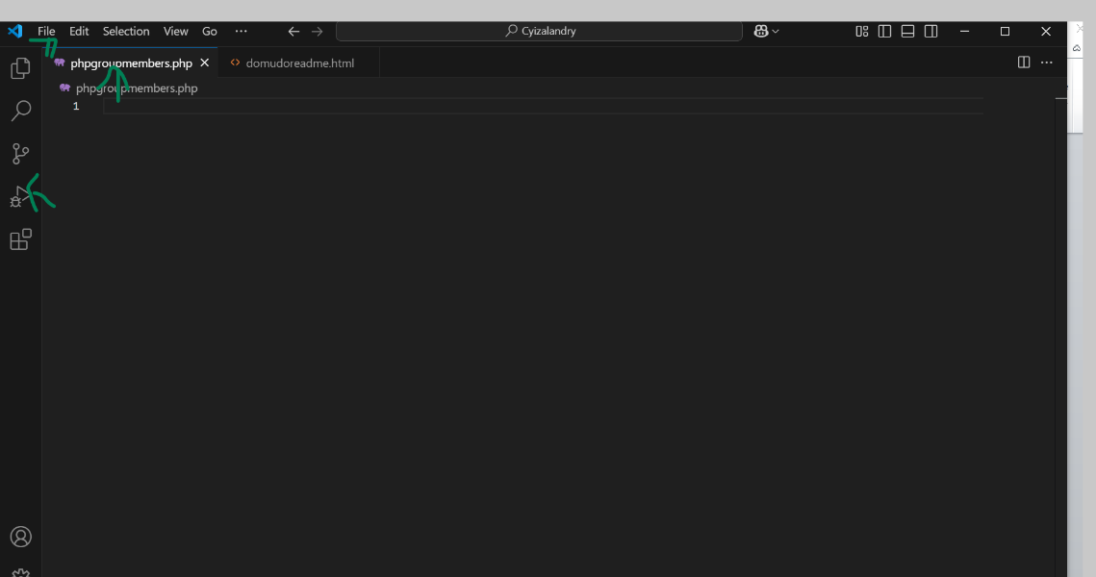

Step8:start code planning and then run and debugging into browser

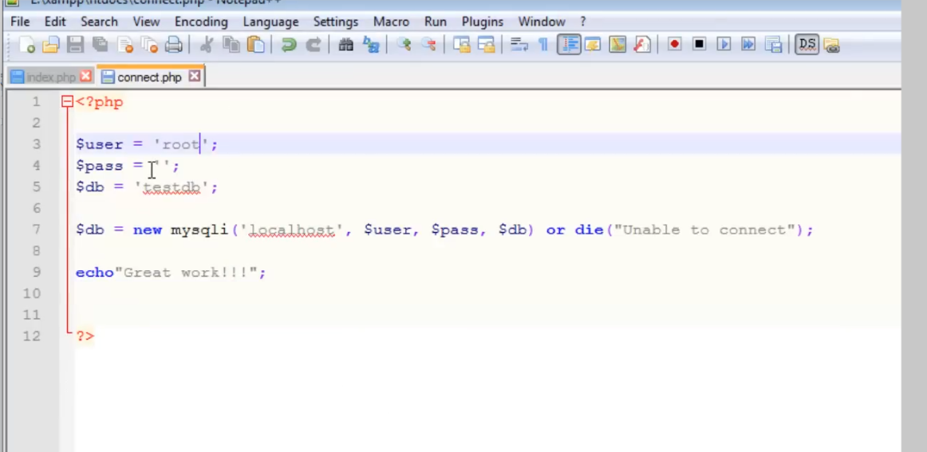

THE END OF

OUR PROJECT 1

